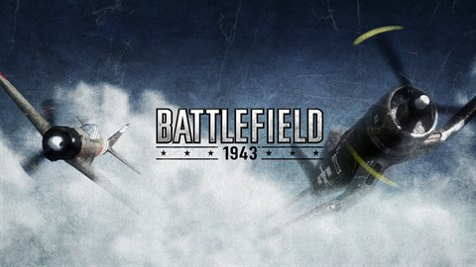

**BATTLEFIELD 1943**

**Developed By:** [DICE](https://www.google.com/search?sxsrf=AOaemvJMrWJ9vrJDxiaUMb8JRpuRxlyI1w:1640620710935&q=EA+DICE&stick=H4sIAAAAAAAAAOPgE-LSz9U3ME0zL87JUOIEsY3STcuMtFSyk630k8vS9ZPzcwtKS1KL4ssyU1Lz0xNzU61SUstSc_ILUosWsbK7Oiq4eDq77mBlBACOsfudTAAAAA&sa=X&ved=2ahUKEwiGn761rIT1AhXURPEDHRcpBlMQmxMoAXoECEIQAw&cshid=1640620977923688)

**Description:** Battlefield 1943 is an online multiplayer World War II first-person shooter video game developed by DICE and published by Electronic Arts for Xbox 360 and PlayStation 3 through digital distribution. It takes place in the Pacific Theater of Operations of World War II.

**Platforms:** Xbox 360, PlayStation 3

**System Requirement:**

* A minimum computer system that will help you access all the tools in the courses is a Pentium 166 or better.
* 64 Megabytes of RAM or better.

**Published By:**

